Лаб.6 - Decode the QR-Code

**Єлін Євген РІ-41 мн**

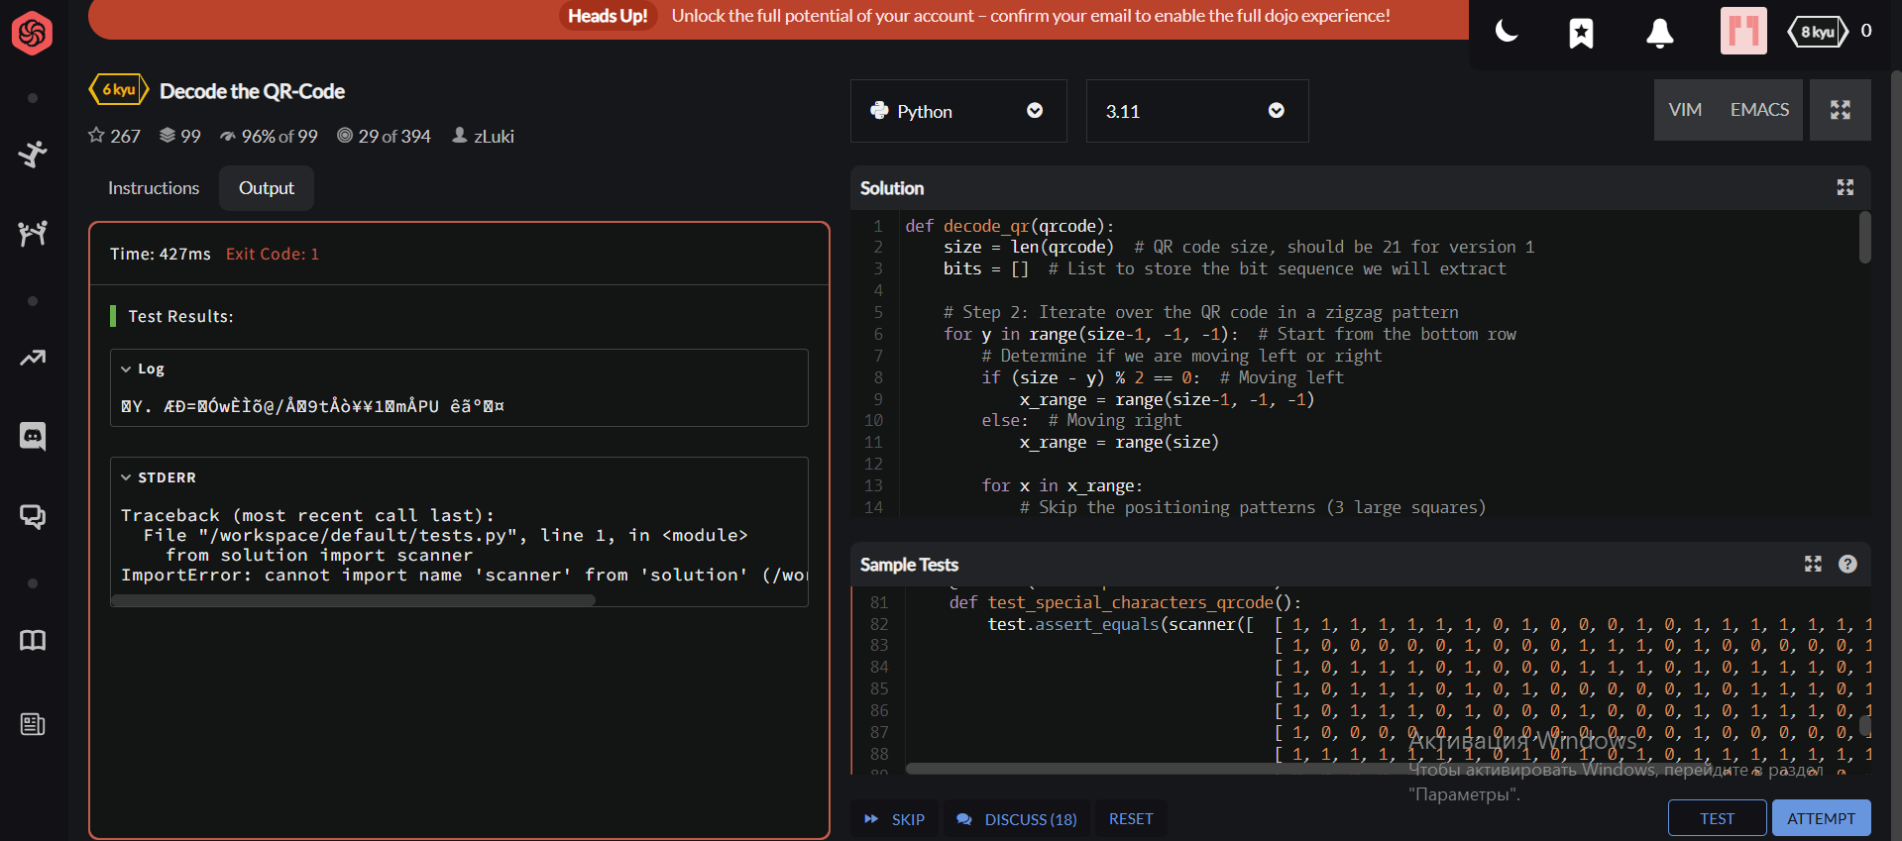

**Код програми на Python:**

def decode_qr(qrcode):

size = len(qrcode) # QR code size, should be 21 for version 1

bits = [] # List to store the bit sequence we will extract

# Step 2: Iterate over the QR code in a zigzag pattern

for y in range(size-1, -1, -1): # Start from the bottom row

# Determine if we are moving left or right

if (size - y) % 2 == 0: # Moving left

x_range = range(size-1, -1, -1)

else: # Moving right

x_range = range(size)

for x in x_range:

# Skip the positioning patterns (3 large squares)

if (x < 7 and y < 7) or (x > size-8 and y < 7) or (x < 7 and y > size-8):

continue

# Check mask condition: ((x + y) % 2 == 0)

mask_condition = (x + y) % 2 == 0

# Get the bit from the QR code (1 is black, 0 is white)

bit = qrcode[y][x]

# Apply mask: flip the bit if the mask condition is true

if mask_condition:

bit = 1 - bit # Flip the bit (0 -> 1, 1 -> 0)

# Add the bit to the sequence

bits.append(bit)

# Step 3: Process the bits to extract the message

# First 4 bits: Mode (we can ignore this as it is always byte mode "0100")

mode = bits[:4]

bits = bits[4:]

# Next 8 bits: Message length (number of characters)

message_length = int(''.join(map(str, bits[:8])), 2)

bits = bits[8:]

# Now extract the message bits (each character is 8 bits)

message_bits = bits[:message_length * 8]

# Convert the message bits into characters

message = []

for i in range(0, len(message_bits), 8):

char_bits = message_bits[i:i+8]

char_code = int(''.join(map(str, char_bits)), 2)

message.append(chr(char_code))

# Return the decoded message as a string

return ''.join(message)

# Test the function with the example QR code

qrcode = [

[1, 1, 1, 1, 1, 1, 1, 0, 1, 1, 1, 0, 1, 0, 1, 1, 1, 1, 1, 1, 1],

[1, 0, 0, 0, 0, 0, 1, 0, 0, 0, 0, 1, 1, 0, 1, 0, 0, 0, 0, 0, 1],

[1, 0, 1, 1, 1, 0, 1, 0, 0, 0, 0, 0, 1, 0, 1, 0, 1, 1, 1, 0, 1],

[1, 0, 1, 1, 1, 0, 1, 0, 1, 0, 0, 0, 1, 0, 1, 0, 1, 1, 1, 0, 1],

[1, 0, 1, 1, 1, 0, 1, 0, 0, 1, 0, 0, 1, 0, 1, 0, 1, 1, 1, 0, 1],

[1, 0, 0, 0, 0, 0, 1, 0, 0, 0, 0, 0, 1, 0, 1, 0, 0, 0, 0, 0, 1],

[1, 1, 1, 1, 1, 1, 1, 0, 1, 0, 1, 0, 1, 0, 1, 1, 1, 1, 1, 1, 1],

[0, 0, 0, 0, 0, 0, 0, 0, 0, 1, 0, 1, 0, 0, 0, 0, 0, 0, 0, 0, 0],

[0, 0, 1, 0, 1, 1, 1, 0, 1, 0, 0, 1, 1, 1, 0, 0, 0, 1, 0, 0, 1],

[0, 1, 0, 0, 1, 1, 0, 0, 0, 0, 0, 1, 1, 1, 1, 0, 0, 0, 0, 1, 1],

[0, 0, 1, 1, 0, 0, 1, 0, 0, 0, 0, 1, 0, 1, 0, 0, 1, 1, 1, 1, 1],

[0, 0, 1, 0, 0, 0, 0, 1, 1, 0, 1, 1, 0, 1, 0, 0, 0, 0, 0, 1, 0],

[1, 0, 1, 0, 1, 0, 1, 1, 1, 1, 0, 1, 0, 1, 0, 0, 1, 0, 0, 0, 0],

[0, 0, 0, 0, 0, 0, 0, 0, 1, 0, 1, 1, 0, 0, 1, 1, 0, 0, 1, 1, 0],

[1, 1, 1, 1, 1, 1, 1, 0, 0, 1, 0, 0, 0, 1, 0, 1, 0, 0, 1, 1, 1],

[1, 0, 0, 0, 0, 0, 1, 0, 1, 1, 0, 0, 0, 0, 1, 1, 1, 0, 0, 0, 0],

[1, 0, 1, 1, 1, 0, 1, 0, 1, 0, 1, 0, 1, 1, 0, 1, 0, 0, 0, 1, 1],

[1, 0, 1, 1, 1, 0, 1, 0, 0, 0, 1, 1, 1, 0, 0, 1, 0, 0, 1, 1, 0],

[1, 0, 1, 1, 1, 0, 1, 0, 1, 1, 1, 1, 0, 1, 1, 0, 1, 0, 1, 0, 1],

[1, 0, 0, 0, 0, 0, 1, 0, 0, 1, 1, 0, 0, 0, 0, 0, 1, 0, 0, 1, 0],

[1, 1, 1, 1, 1, 1, 1, 0, 0, 1, 1, 1, 1, 1, 0, 1, 0, 0, 0, 1, 1]

]

# Call the function and print the result

decoded_message = decode_qr(qrcode)

print(decoded_message) # Expected Output: "Hello"